Development Aspects
Prepared by: TSc.

User Interface
Hvordan præsenterer produktet sig for brugeren rent betjenings mæssigt? Skitsér for- og bagpladen, og beskriv hvordan apparatet skal forbindes til “omverdenen”. Beskriv hvordan apparatet betjenes i alle situationer

Mechanical Design/Styling
Hvordan ser apparatet ud? Størrelse og vægt? Anvendte farver, knapper og displays? Passer det design mæssigt med andre PTV (eller andre) apparater, det må forventes, det skal kunne arbejde sammen med?

Technical Description
Beskrivelse af apparatet og de anvendte kredsløb på - mindst - blok-diagram-niveau.

Main Instrument Functions

Instrument Block Diagram

Description of Instrument Block Diagram

PT 5201 BlackBurst generator

Main Functions
The diffenrent signal-types present in the ‘old’ BB-generator shall be available in the ‘new’ generator.
Included in the option are:
- 3 black and burst outputs.
- Running both G / M systems.
- Individually timeable
- Fine timing with about 0.14ns resolution.

Product requirement: TBD.

Analog Black Burst Outputs:
- Connector: BNC
- Impedance: 75 Ω
- Return Loss: >36dB, upto 5MHz
- Amplitude nominal: -300mV ±2%
- Timing range PAL: ±4 fields
- Timing range NTSC: ±2 fields
- Timing resolution: 1° f_{SC}
- Sc-H phase: default 0°, adjustment to ± 180°, resolution <5°
- S/N Ratio: 60dB unweighted to 5MHz
- Jitter: ± 0.5ns, locked to input

Block Diagram

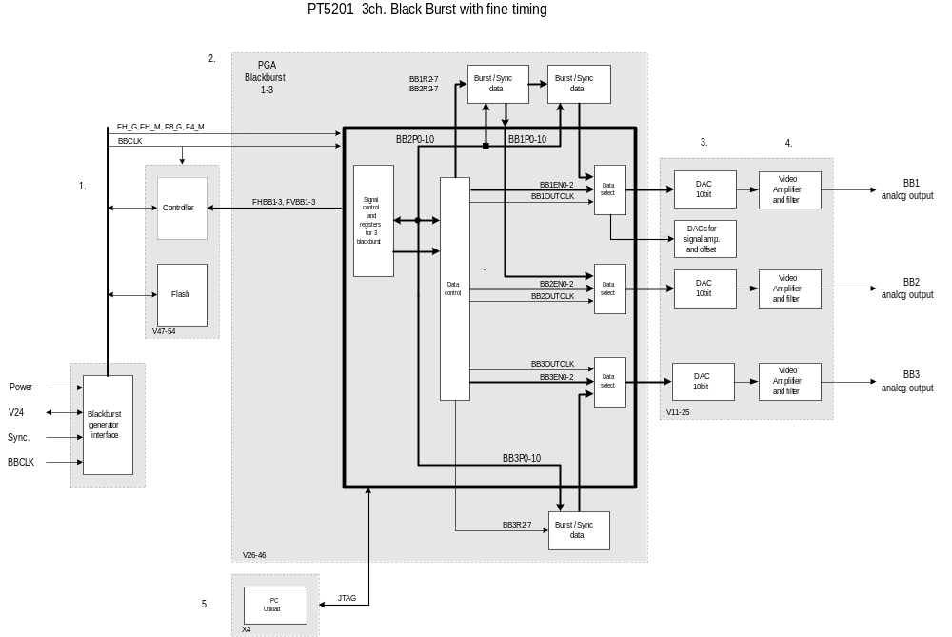

Block Diagram Description
The block diagram consists of:
1. One Processor systems with a flash.
2. PLD's with logic to control 3 BlackBurst outputs. Sync and BlackBurst data in flash.
3. Dac’s
4. Output drivers for the BNC connectors.
5. Upload

1. The processors handles the communications with the master processor (ControllerCard), e.g. commands, level detector, errors and controls the 3 blackburst generators.
The processor-system on the option will be a 16-bit system to meet the new requirements.

2. The PLD's contains logic to control 3 BlackBurst generators with the following main functions:
- communicate with the controller-system.
- running data sequenzer for the dac’s.
The priciple of PLD's is to get the right phase a linetype for the next line to perform the right sync and burst signal. Under initialization of the balckburst-generator the registers in the PLD are loaded with correct data and the generator can then start working with the right timing.

- For each BlackBurst channel the dac are 10 bit’s to maintain the accuracy from former balckburst generators

4. The video-amplifier moduls consist of two op-amps with a filter and an output circuit to obtain 75 ohm on the BNC outputs.

5. To upload the PLD from a PC there is a plug.

New Components and Technologies
All digital and analog components will if possible have only ±3.3 V supply to reduce power consumption.
Use of flash prom’s to make data reprogramable.
Use of more complex components which will increase the risk of obsolete component but decrease the costs.
E.g. the video-dac's are placed in one chip.
Her beskrives nødvendige nye komponenter og anvendte teknologier - ikke blot kredsløbsmæssigt men også produktionsmæssigt.

Development Time & Cost

Her angives det estimerede ressourceforbrug til gennemførelse af de planlgte udviklingsfaser:
Interne udviklingstimer, externe konsulenttimer, udviklingsmaterialer herunder prototyper opsplittet på faser.

Production / test Cost

